**Directions: You have 60 minutes to complete the following 25 multiple-choice questions. Choices A through D are answer choices for every problem. Choice E) NOTA stands for “none of these answers.”**

**Note: A Tetris board has dimensions of 10x20**

Shown below are all the possible tetrominoes.

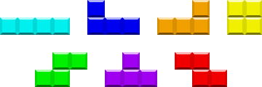

26) Tetris is a game that uses pieces called tetrominoes. How many unit squares are in one tetromino?

**A) 1 B) 2 C) 3 D) 4 E) NOTA**

27) If the T-block has a perimeter of 10 then what is the area of that T-block?

1. **2 B) 3 C) 4 D) 5 E) NOTA**

28) If only whole Tetris pieces are used, how many whole Tetris pieces are required to make a 3x3 square?

1. **2 B) 3 C) 4 D) 5 E) NOTA**

29) What is the sum of the internal angles in the following three pieces: T-block, L-block, and Line Block?

1. **360° B) 720° C) 1440° D) 2160° E) NOTA**

30) Niral has been playing Tetris nonstop for many hours and decides to take a break by swiming in his pool. Coincidentally, when seen from above, the pool is a perfect square and has the same dimensions as a square piece in Tetris, with a depth of 2 meters. Because of the nonstop playing that Niral did earlier he also sees the resemblance and wonders what the space diagonal of the pool is. If one side length of the pool is 4 meters, what is the space diagonal of the pool?

**A) 3 B)**  **C)**  **D) 6 E) NOTA**

31) Cayle wants to go to the store from her house but can only travel the roads that are outlined in black of the map provided. How many different ways can she get to the store from her house if she can only move down or right?



**House**

**Store**

**A) 7 B) 12 C) 14 D) 24 E) NOTA**

32) There are two similar shapes A and B that are made up entirely of Tetris blocks. The side lengths of A are larger than the side lengths of B by a factor of 1.25. What is the ratio of the area of shape A to shape B?

**A)**  **B)**  **C)**  **D)**  **E) NOTA**

33) This year is the 30th anniversary of the wonderful game of Tetris! How many diagonals are in a 30-gon?

1. **400 B) 405 C) 425 D) 450 E) NOTA**

34) Jamie was playing Tetris and there was a glitch in the game! The blocks that were already placed for some reason formed a figure in the middle of the board. If the figure that was formed were to be on a coordinate grid, it would have its vertices on points (2,3), (10,15), (5, 2), and (2, 7). What is the area of the figure with these vertices?

**A) 11 B) 22 C) 33 D) 38 E) NOTA**

35) Given the figure below, what are the coordinates of the centroid? (Assume the interval between each mark is one)

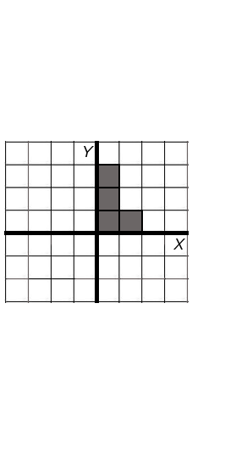

**A) (****, 1) B) (1,** **) C) (****, 2) D) (2,** **) E) NOTA**

36) Nilay has been playing Tetris all afternoon long in a house without an air conditioner in the middle of the summer. After playing for so long he hears the ice cream truck outside and decides to buy an ice cream cone in order to cool off. If the ice cream cone has a diameter of 5 inches and a slant height of 5 inches, what is the volume of the cone?

1.  **B)**  **C)**  **D)**  **E) NOTA**

37) Andrew has been playing Tetris from 1:12 PM to 8:37 PM. Find the number of degrees that the minute hand has swept in this time period on an analog clock.

**A) 2160° B) 2310° C) 2520° D) 2670° E) NOTA**

38) In order for Nick Young to be as good as Nick Yang at Tetris, it would require him to play 7 hours and 37 minutes. If Nick Young decides to play all of that in one afternoon and begins at 12:48 PM, what will the angle between the hour and minute hand be on an analog clock when Nick Young is finished playing?

**A) 51.25° B) 102.5° C) 205° D) 307.5° E) NOTA**

39) When playing Tetris, a good player not only looks at the piece that is dropping and where it will go, but also the next piece and the piece on hold in order to plan the moves ahead. In this particular case, the four points that were described form a cyclic quadrilateral. If one angle in the cyclic quadrilateral is 134°, how many degrees are in the opposite angle? (A cyclic quadrilateral is a quadrilateral that is inscribed in a circle)

1. **46° B) 56° C) 134° D) 180° E) NOTA**

40) Pranshu has gotten four line pieces in a row. If each Tetris piece is independent from each other and has the same probability, what is the probability that the next piece is also a line piece?

1.  **B)**  **C)**  **D) 0 E) NOTA**

41) If the statement “If I am playing Tetris, then I am sitting at my desk” is true, then is the statement “If I am sitting at my desk, then I am playing Tetris” also true?

**A) Yes B) No C) Depends which tetromino you are speaking of.**

**D) I ♥ tetris. E) NOTA**

The Euler Circuit and Euler Path follows an algorithm called “Fleury’s Algorithm.” The algorithm is stated below:

1. Make sure the graph has either 0 or 2 odd vertices.

2. If there are 0 odd vertices, start anywhere. If there are 2 odd vertices, start at one of them.

3. Follow edges one at a time. If you have a choice between a bridge and a non-bridge, always choose the non-bridge.

4. Stop when you run out of edges.

An odd vertex is defined as a vertex where it has an odd number of edges meeting at/starting at that vertex. Shown below is a figure to demonstrate the definition.

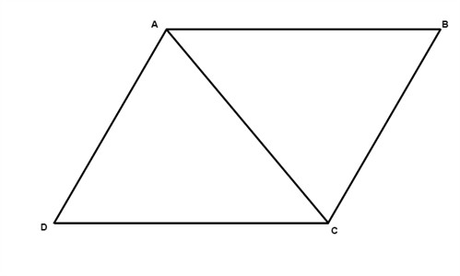

Vertices A and C are odd vertices while vertices B and D are even vertices.

42) An Eulerian Circuit is a figure that has zero odd vertices. Using the given information, how many Tetris pieces is (are) a Eulerian circuit?

**A) 0 B) 1 C) 2 D) 3 E) NOTA**

43) An Eulerian Path is a figure that has two odd vertices. Using the given information, how many Tetris pieces is (are) a Eulerian path?

**A) 0 B) 1 C) 2 D) 3 E) NOTA**

44) When playing Tetris on a classic arcade machines, the game consists of a joystick (a sphere on a rod) and two identical cylindrical buttons used for rotating and placing the pieces. If the volume of the sphere is equal to the sum of the volume of the each cylinder and the radius of both the sphere and the cylinders are , what is the height of each cylinder in relation to ?

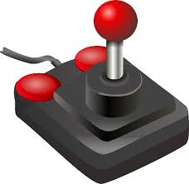**A)** **R B)** 

**C)** **R D) 1 E) NOTA**

45) Nick is playing with magical Jell-O that can change its shape to fit in any container. If this Jell-O is put perfectly into a bowl that is shaped like a cylinder that has radius  and height 8, how many Tetris pieces can be made from this amount of magical Jello-O? (Each unit cube of a Tetris block has side length of 1)

**A) 16 B) 17 C) 18 D) 19 E) NOTA**

46) Nitharsan loves Tetris so much he that literally sleeps in a bed that is shaped like the T-block. If the bed has to be fully covered with a protective layer to prevent it from corroding and the shortest side has a length of 2 meters, how much of the protective layer is needed to cover the entire surface of the bed? (The whole bed must be covered, even the bottom and sides)

**A) 60 B) 64 C) 68 D) 72 E) NOTA**

47) While playing Tetris, Jessie’s hand got a cramp. The time, in minutes, it takes for the cramp to fully heal is equal to the area of a regular shape that has the same number of sides as the number of different tetrominoes. If the shape has side lengths of 8 and is circumscribed about a circle with area 36π, how long will it take the cramp to fully heal?

**A) 168 B) 336 C) 504 D) 672 E) NOTA**

48) Dorren wants to play Tetris on her computer but she forgot his password! She uses the hint and it says that the password is the sum of the number of faces in all the Platonic Solids. What number should she enter for her password?

**A) 20 B) 30 C) 40 D) 50 E) NOTA**

49) One day Stacy wanted to play Tetris on the iPad. She realized that the home button on the iPad was circular. If the radius of this button is 5mm, what is the area of his button in mm2?

**A) 5 B) 25 C) 5π D) 25π E) NOTA**

50) If there is a triangle with area 50 and the unit square of a Tetris piece has an area of 1. What is the minimum number of whole Tetris pieces required to fill the triangle?

**A) 12 B) 13 C) 14 D) 15 E) NOTA**

